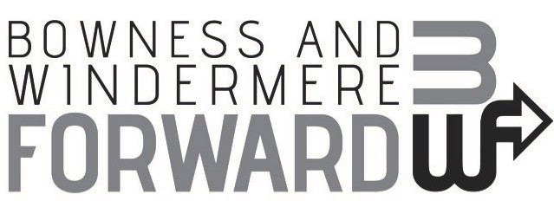

Board Minutes
Thursday 1st October 2020 at 6pm
Via Zoom

Present

Sophia Newton (Chair), Helen Moriarty (PM), Ruth Leahy (SLDC Officer), Andrew Simon (Windermere Lake Cruises), Cllr Robin Ashcroft (SLDC), Adrian Faulkner (BWCOT), Scott Keenen (BWCOT), Ali Tordorff (Fidget Design), Amanda Snowie (Windermere Backpackers).

Apologies

Cllr Dyan Jones (SLDC Councillor), Paul Foster (FSB), Gill Holmes (CCC), Vicky Hummersone (Invegarry Guest House) Janett Walker (Flock), Peter Hamilton (WTC),

MINUTES

- Welcome and Apologies
SN welcomed all particularly members from the Lakeshore Cinema team. Attendees introduced themselves and apologies were noted. Hanna Latty will no longer be attending Board meetings due to LDNPA resource challenges. Hanna was thanked for her contributions to date.

- Lakeshore Cinema Review
HM summarised the review report provided to Board members and added the benefits of the local discount and the quality of engagement thanks to the social media support provided voluntarily by Flock PR and Events. RL thanked all involved and recognised the amount of work involved in getting the event to the delivery stage. All agreed it was ready to go when large scale events are allowed again. AT asked how much of the co-ordinators time was spent on the project.
ACTION | HM to send overview of time spent on the Lakeshore Cinema event to date
- Windowmere
The group discussed the ‘Windowmere’ proposal provided in advance of the meeting. The idea was well received and endorsed by the group.

Additional suggestions included approaching Lakeland Arts at Windermere Jetty to take part and Lakeland Plastics.

AF confirmed that BWCOT would not run their annual business window display competition and instead will share the trophies and help to judge the business windows. This was appreciated by the group. AF suggested approaching WTC to judge the residential windows.

AT demonstrated the recycled milk bottle stars which could be integrated into the project.

AF led a discussion regarding the involvement of local businesses and the terms of reference for BWF. He drew attention to the question of having 7 business representatives at Board meetings. HM confirmed that 7 businesses are only required should a vote be deemed necessary. Consensus agreement is almost always reached and on this occasion a vote was not required.

All agreed that greater business representation at Board meetings would be welcome but it was noted that wider engagement and support for working groups was more important regarding project delivery than physical presence at Board meetings. SN noted that Board meetings needed to be efficient and relevant to attract business members and honour their time.

ACTIONS |  | HM approach businesses outlined above and confirm WTC involvement in the project.  HM include the milk bottle stars in the inspiration tool box for participants with support form AT.  SN to talk to local businesses about Board membership and engagement  SN to set up working group for Windowmere  HM to confirm CCC funding proposal result  HM review BWF’s terms of reference to reflect wider engagement and membership (with support from RL) and efficient project delivery.  ALL to confirm terms of references at the next meeting
- BWF Budget

SN led a discussion based on the funding report provided in advance.

The group endorsed the proposal to utilise the co-ordinators time on a project delivery basis rather than a set number of hours per week.

Cllr Ashcroft asked if the group had considered establishing a BID similar to Kendal and Ulverston. The group noted that a BID had attempt had been unsuccessful in the past but it was worth considering again for the area. RL has researched the potential project income and benefits and will share.

ACTIONS |  | RL to share BID funding research with Chair, Vice Chair and co-ordinator
- AOB

RL updated the group regarding SLDC’s current mini master plan project for The Glebe. BWF are on the stakeholder group and the consultants will be in touch when appropriate.

6. Next Board Meeting Dates

- 10th December @ 4pm
- 11th March @ 4pm
- 10th June @ 4pm
- 9th September @4pm
- 9th December @4pm

